Name: _Jihad Alsahori__________________________

|  |
| --- |
| **ASSIGNMENT GOALS:**   1. **Model/Implementan entity of your own choosing:**    1. **Its Structure**    2. **Its Functionality** 2. **Gain more experience with custom Classes.** 3. **Use UML to document/communicate your design.** |

(20 Points)

1. **Read Pragmatic Programmer Textbook – start of Chapter 2 pp 27 ~ 37 (a Pragmatic Approach)**
2. **Read Java Textbook Chapter 6 - “317 – 389”.** Much of this material will be a review of what was covered in class, but it’s a worthy reinforcement. (20 Points)

Complete the following exercises at the bottom of page 393 (**short answers**):

2) Yes class is a blueprint and house is an instance .

4) Yes it’s good, because we should not expose all the details of the class to outside scope because it's called abstraction.

9) Field and attribute are the same things in class.They are used interchangeably.

11)  If no parameterized constructor is defined, no constructor defined with parameters, Java provides default constructor. But if we define any parameterized constructor , we must define the constructor explicitly.

**(2a)**

**Model a physical entity as a Java Class (70 points) – focus on Encapsulation**:

NOTEpackage up programming assignment Classes under:**edu.cuny.csi.csc330.lab4**

**This is an Object Modeling/Programming exercise – albeit around1 (maybe 2) Object(s).**Using the Radio Class implementationprovided as a point of reference, think of a common (or maybe, not so common) device or appliance that’s *worthy* of modeling as an Object. Consider the following:

* 1. The basic operations/functionality of your device/appliance become public methods of the implementing Class (e.g., on, off, go, start, stop, … )
  2. The internal structure (or how you envision the internal structure) of your device/appliance become the data members of the implementing Class. This would include the internal piece-parts of the device and well as “state components”. For example, modeling a bread toaster might require a “heat coil” as well as a “power on/off”indicator.
  3. In the spirit of modularity, reusability, etc., private/protected methods can and should be used to implement sub-tasks performed by public methods.

In addition to Class members supporting (a) (b) (c) above, you also need to implement:

* Either a **public void main(String [] ){}** method or a second “launch” Class whose only job will be to:
  + Create an instance of your modeled Class
  + Invoke a sequence of methods on that instance that demonstrates the functionality and basic usefulness of what you built.
* A “String toString()” method – allowing you to display ‘thestate’ of the Object Instance.

What do we mean by **the state** of the Instance? The collective value of all data members ‘at a moment in time’ is considered the instance’s **state**. *That’s a valid definition of state, but for this lab, customize the Class’toString() method to display values of data members that are considered significant to the device/application’s operation.*

**Note**: Refer to the Radio Class’*toString()* and *main()* methods as a guide. Also refer to the Radio’s execution output below –showing that a single instance has beencreated, and taken through a series of operations (method invocations). At critical points, a “toString()” representation of the instance’s state is displayed to the console using System.out.println()or like method.

|  |
| --- |
| **Slight variant: or, you can choose to model a simulation that proves a hypothesis.** Something similar to the Classes implemented under our edu.cuny.csi.csc330.stats package …  To be expanded on in class, but the general idea is to model the proof of a hypothesis that may be a bit counterintuitive or difficult to verbally explain as a proof. |

**Replace the output below with yours!**

|  |
| --- |
| New Tv:  TV [channel =null, Connection=null, Brightness=0, Internetspeed=0.0mph  isTurnedON=false, TVOnDate=null  isTurnedOFF=false, TVOFFDate=null, The TVSignal: false]  TheSecondDay  TV [channel =15, 16, Connection=Strong, Brightness=75, Internetspeed=0.0mph  isTurnedON=false, TVOnDate=null  isTurnedOFF=false, TVOFFDate=null, The TVSignal: false]  Morning News Channels  TV [channel =15, 16, Connection=Strong, Brightness=75, Internetspeed=200.0mph  isTurnedON=true, TVOnDate=Tue Nov 01 17:54:52 EDT 2022  isTurnedOFF=false, TVOFFDate=null, The TVSignal: true]  Night News Channels  TV [channel =15, 16, Connection=Strong, Brightness=75, Internetspeed=0.0mph  isTurnedON=true, TVOnDate=Tue Nov 01 17:54:52 EDT 2022  isTurnedOFF=false, TVOFFDate=null, The TVSignal: true] |

**(2b) UML Class Diagram (10 points)**

Provide a **simple** UML Class diagram that documents the structure and functionality of the Class (or Classes) you implemented.

* 1. Class Name
  2. Non-public members (-) or (#)
  3. Public Methods (+)

**Note: You may hand-draw and scan the image, or use a diagramming tool like NClass, Visio, draw.io, etc. or better yet, an online tool like** <https://www.lucidchart.com/pages/> (LucidChart)  **See Radio Example below:**

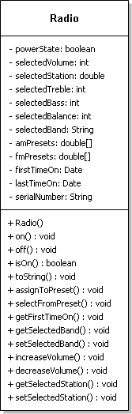

Image is Pasted Below

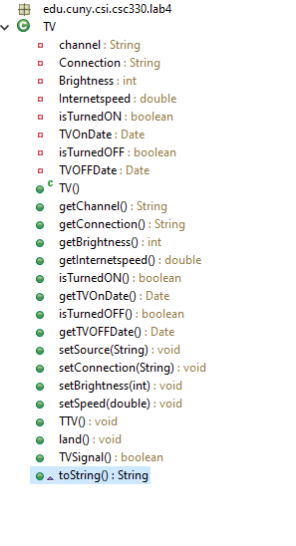

**Some example device/entities worthy of modeling as a Java Class:**

1. **Just about any household appliance**
2. **A simple communication device**
3. **Moving Ground or Air Vehicle**
4. **A living organism – *real or imagined*.**
5. **A secondary computer device (disk, printer/scanner/fax, etc.).**
6. **Musical Instrument or Related Device**
7. **A non-existent device such as:Time-travel Machine**